Taskify:
Designing and Developing
a Task Management Web Application
Computing Project

REPORT

Edmund Favour Edem Hogan
(P00193367)
September 2026 AfriHUB

Abstract
Task management is a crucial aspect of any productive activity; it makes clear what needs to be done to achieve specific goals. While many digital tools exist for this, the traditional pen-and-paper to-do list remains a common option. But, as many people have experienced, this method comes with its limitations: paper lists can be lost or damaged, are difficult to back up, and become messy with edits. Furthermore, they cannot be searched, sorted, or reorganised efficiently. Digital to-do lists emerged to address these challenges, making it easier to manage tasks. The developed artefact, Taskify, builds on this concept by providing a system with unique features beyond the core functionalities of creating, editing, completing, deleting, and searching for tasks. These features include a completion percentage tracker, postponing tasks, location-based reminders, routine reminders, and more. Built on a solid architecture with a fast and powerful technology stack, the web application results in being a useful tool that can greatly improve the productivity of its users.
Table of Contents
Chapter 1: Introduction 1
1.1 The System Developed 2
1.2 Methodology & Framework Justification 2
1.3 The Solution that Emerged 2
1.4 Main Aim & Objectives 2
1.5 Overview of the Remaining Chapters 3
Chapter 2: Analysis 4
2.1 Introduction 5
2.2 Requirements 5
2.3 Use Cases 8
2.4 Architecture 8
2.5 Conclusion 9
Chapter 3: Design 10
3.1 Introduction 11
3.2 Structural Model 11
3.3 Behavioural Model 13
3.4 Conclusion 13
Chapter 4: Implementation 14
4.1 Introduction 15
4.2 Choice of Programming Language 15
4.3 System Cutover 16
4.4 Data Migration 17
4.5 Training 17
4.6 Conclusion 17
Chapter 5: Other Project Issues 19
5.1 Introduction 20
5.2 Project Management 20
5.3 Risk Management 22
5.4 Configuration Management 23
5.5 Testing 23
5.6 Conclusion 23
Chapter 6: Conclusion 24
References 25
Appendices 26

Chapter 1: Introduction

The System Developed
This project is centred on the development of Taskify, a task management web application designed to serve all types of users, from students and teachers to business owners and everyday individuals. The primary problem addressed by this system is the inefficiency of managing tasks with the traditional pen-and-paper method. This method creates several drawbacks: paper lists are easily lost or damaged, are difficult to back up, and do not have support for reminders or alarms. Furthermore, they do not sync across devices, offer limited space, and cannot be easily searched, sorted, or reorganised.
As a solution, Taskify provides a digital platform where users can create, edit, and organise tasks that are securely backed up to the cloud and accessible from any device. Specifically, users will be able to make an account, log in and log out, add, edit, and complete tasks, flag tasks as important, delete tasks to trash, include task descriptions, add subtasks, categorise tasks into custom task lists, and search for tasks. Future updates to the application will introduce unique features that will make Taskify stand out from its competitors.

Methodology & Framework Justification
The project was accomplished using the Agile development methodology. This method was chosen primarily for its iterative approach to software development, as it supports the future intention to incrementally introduce new features or update existing ones. Alongside the Agile framework, object-oriented development principles were also used as a coding technique, for example, within TypeScript modules.

The Solution that Emerged
The solution that emerged was a web application developed with a modern technical architecture. The front-end of the system was built using the JavaScript framework, SvelteKit (v2.22.0), powered by the Svelte language (v5.0.0) and TypeScript. The user interface (UI) elements were developed using HTML5 and CSS3. For the backend, SvelteKit and TypeScript again handled the server-side logic, and the database was constructed and managed using the Qdrant Vector Database v1.15.0. To ensure a stable final product, the web application was tested for cross-browser compatibility across Google Chrome, Microsoft Edge, and Mozilla Firefox browsers during development.

Main Aim & Objectives
The primary aim of this project was to design and develop a to-do list web application, Taskify. To achieve this aim, the following objectives were established at the project's outset:
- To perform a detailed analysis of the proposed system's requirements
- To design the system architecture and user interface
- To develop the proposed system and produce a functional working prototype
- To run tests on the working system and fix any bugs and errors discovered
- To document the project lifecycle and produce a final report

Overview of the Remaining Chapters
The remainder of this report details the work undertaken throughout the project. Chapter 2 presents the analysis of the system, outlining the functional and non-functional requirements, use cases, and the system's architecture, including an initial class diagram. Following this, Chapter 3 details the system design, presenting the final structural and behavioural models. Chapter 4 describes the implementation process, covering the development of the application's core components and training. Chapter 5 discusses other project issues, providing an account of the approach taken to project management, risk management, configuration management and testing. Finally, the report concludes in Chapter 6 with an evaluation of the project's success against its initial aims and objectives, and comments on potential future developments.

Chapter 2: Analysis

Introduction
This chapter performs an analysis of the Taskify system. It sets out to identify what the system needs to do to achieve its aim. It does this through first outlining the system’s functional and non-functional requirements, the use cases that show what users can do, and the basic architecture plan. This analysis gives the foundation for the system design in the next chapter.

Requirements
This section outlines the requirements that shaped the development of the Taskify system. These specifications are broken down into two key categories: the functional requirements, which define what the system does, and the non-functional requirements, which define how the system performs.

Functional Requirements
The functional requirements for the Taskify system were prioritised using the MoSCoW technique. This is a method used in project management to help stakeholders understand and agree on the importance of each requirement, particularly within a time-boxed project (Atlassian, 2025). The name itself is an acronym that stands for the four priority categories: Must have, Should have, Could have, and Won't have this time (Atlassian, 2025). This framework ensures that a viable product is delivered by distinguishing between non-negotiable needs and desirable features that can be addressed later (Aserg, 2022).
Must Have (M)
These requirements are the core functionality that was implemented in the final prototype:
- The system must allow a user to register for a new account using an email and password, or authenticate using a Google account.
- The system must allow a registered user to log in and log out.
- The system must provide users with the ability to change their username and password.
- The system must allow users to change their profile picture.
- The system must allow users to delete their accounts.
- The system must allow users to add new tasks to the ‘Inbox’, ‘Today’, ‘Important’, or a custom list.
- The system must feature a ‘Today’ list for tasks to be accomplished on the current day.
- The system must allow users to edit task titles.
- The system must allow users to mark tasks as completed.
- The system must allow users to flag tasks as important.
- The system must allow users to duplicate tasks
- The system must allow users to delete tasks to the trash.
- The system must allow users to restore tasks from the trash.
- The system must allow users to empty the trash (permanently deleting tasks).
- The system must allow users to include detailed descriptions for a task.
- The system must allow users to attach files to a task and preview the file in a modal.
- The system must allow users to add subtasks to a primary task.
- The system must be able to search for tasks across all lists.
- The system must allow users to create, rename, add to, and delete custom task lists.
- Tasks and activities of the same account must sync across devices.
Should Have (S)
These requirements were valued as important for improving the user experience, but were not essential for the initial prototype. They are considered high-priority for future iterations.
- The system should allow users to set due dates and times for tasks.
- The system should allow users to set reminders for tasks.
- The system should remind users of tasks with upcoming due dates or times.
- The system should allow a user to postpone a ‘Today’ task to another day.
- The system should automatically add tasks due on the current day to the ‘Today’ list.
- The system should provide task suggestions from other lists to add to ‘Today’.
- The system should have a completion percentage tracker to show progress within a task list.
Could Have (C)
These requirements were identified as desirable enhancements but were of a lower priority than the 'Should Have' features.
- The system could allow users to set routine reminders for a single task (e.g., every hour).
- The system could allow a user to mark a task as ‘won’t do’.
- The system could allow users to make a task location-based, triggering a reminder upon arriving at and leaving a specific location.
- The system could enable users to include due dates and reminders through natural language interpretation upon task entry.
- The system could allow users to customise when their 'day' begins (e.g., 5 am instead of 12 am) for the purpose of refreshing the 'Today' list.
- The system could allow users to share their task lists with other users and enable collaboration on projects.
- The system could be accessible and interactable without an internet connection.
Won't Have (W)
This represents a specific functionality that was explicitly decided would not be part of the project at this stage.
- The system will not have an installable mobile application for iOS or Android.

Non-functional requirements
Alongside the functional requirements, the following non-functional requirements were established to define the system's operational expectations and the overall user experience.
- Have an intuitive and easy-to-navigate user interface, so a new user can understand how the app works without extensive training.
- Must be fully responsive to enable seamless rendering on various screen sizes, like desktop, tablet, and mobile web browsers.
- Should load and respond to user interactions in under 3 seconds on a standard internet connection.
- User passwords must be securely hashed before they are stored in the database to prevent unauthorised access to user accounts.
- The HTTPS protocol will be used to encrypt data transmitted between the client and the server.
- Must be compatible and render correctly on the latest stable versions of major browsers.
- Must be available 24 hours all the time.

Use Cases
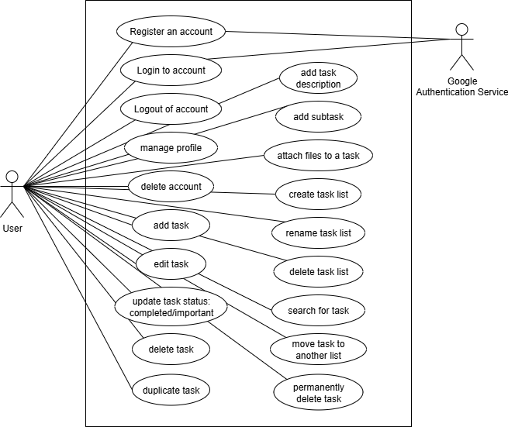
Figure 2.1: Use case diagram
The above diagram (Figure 2.1) defines the use cases for the Taskify system, illustrating the goals that actors can achieve. These use cases are derived from the ‘Must Have’ functional requirements and will be modelled in a Use Case diagram below. The use case has two actors: the primary actor being the 'User' and the external system actor being the ‘Google Authentication Service’.

Architecture
This section presents a high-level overview of the proposed system architecture for Taskify. It outlines the technologies chosen for development.

System Architecture Description
The system is designed with a modern architecture where the front-end will be developed using the JavaScript framework, SvelteKit version 2.22.0, using the Svelte language version 5.0.0, and TypeScript. Standard User Interface (UI) elements will be built using HTML and CSS. For the backend, SvelteKit and TypeScript will also handle the server-side logic. The database will be constructed and managed using the Qdrant Vector Database version 1.15.0. To ensure cross-browser compatibility, the web application will be tested across Google Chrome, Microsoft Edge, and Mozilla Firefox.

Initial Class Diagram
Following the architecture description, the initial class diagram for the system is shown below:
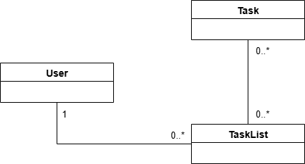
Figure 2.2: Initial Class Diagram
The above diagram (Figure 2.2) presents the static structure of the system at a high level. This model identifies the key classes of the system—User, TaskList, and Task—and the basic relationships between them. At this stage, the diagram focuses on the associations and multiplicities, showing that a User can own multiple TaskLists, and that each TaskList can contain multiple Tasks, and a Task can belong to multiple TaskLists, reflecting a many-to-many relationship. A more detailed version of this diagram, including attributes and methods and more specific relationships, is presented in the Design chapter.

Conclusion
The analysis of the Taskify system has been detailed. It defined the functional and non-functional requirements using the MoSCoW technique, identified the use cases in a use case diagram, and discussed the system’s architecture, including modelling an initial class diagram. These analysis specifications will now be used as a guide to inform the detailed design in Chapter 3.

Chapter 3: Design

Introduction
This chapter discusses the design for the Taskify system. It creates a technical blueprint for how the app was put together and would operate based on the analysis in Chapter 2. The design is broken down into two main sections. The first one is the Structural Model, which shows the different classes and how they are related. The second one is the Behavioural Model, which shows how those classes would interact with each other to get things done.

Structural Model
This section illustrates the final structural model for the Taskify system in the detailed class diagram below (Figure 3.1). It shows all the main classes, their attributes and methods, and how they relate to each other.
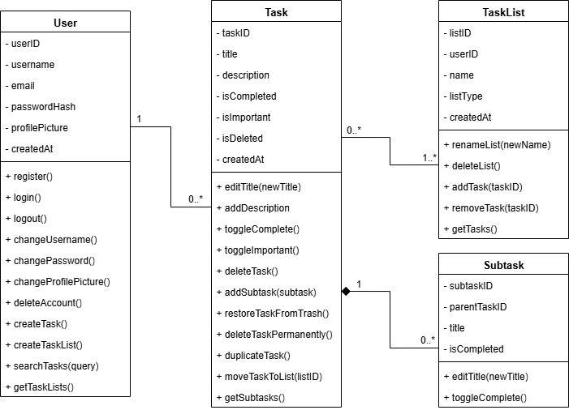
Figure 3.1: Final Class Diagram

The Classes
- User: This class holds all the information for a user's account, like their username and passwordHash. It also contains all the methods for managing the account, such as register() and login(), as well as methods for creating tasks and lists, and for searching.
- TaskList: This class represents a list that holds tasks. It has a name and a listType attribute, which is used to tell if the list is a custom one made by the user or a smart list like 'Today' or 'Important'.
- Task: This is the core class of the application. It stores everything about a single to-do item, including its title, description, and whether it is isCompleted or isImportant. The methods here cover all the actions you can do with a task, like toggleComplete(), deleteTask(), and moveTaskToList().
- Subtask: This is a simpler version of a task that is always attached to a parent Task.

Relationships Between the Classes
The connections between the classes define how the system works:
- One User can own zero or many (0..*) Tasks, and a Task belongs to only one (1) User.
- A TaskList can hold zero or more (0..*) Tasks, and a Task can belong to one or more (1..*) TaskLists, e.g. a custom list and the ‘Today’ list. This is the key relationship that lets a single task appear in multiple lists at the same time.
- Finally, the relationship between Task and Subtask is a composition, which is shown by the filled-in diamond. This means a Subtask is a part of a Task and cannot exist by itself. If a Task is deleted, all of its Subtasks are deleted along with it.
- A Task can have zero or more (0..*) SubTasks, and a SubTask can only belong to one Task (1).

Behavioural Model
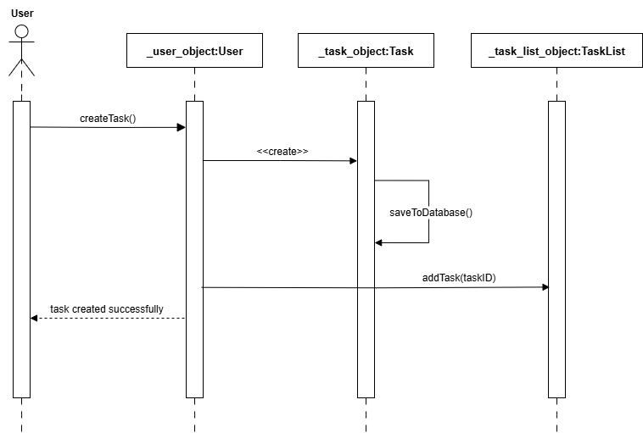
Figure 3.2: Sequence Diagram for Creating a Task
This section shows the behavioural model for the Taskify system. A sequence diagram is used to show how different objects in the system interact with each other step-by-step to complete a process.
The diagram above (Figure 3.2) shows the sequence for the 'Create Task' use case. It shows how the User actor starts the process, and how the :User, :Task, and :TaskList objects work together to create a new task, save it, and add it to the correct list.

Conclusion
This chapter has laid out the detailed design of the Taskify system. It first presented the structural model, which consisted of the final class diagram showing all the classes, the attributes and methods, and their relationships. Then, it introduced the Behavioural Model with a sequence diagram showing how objects interact to create a task. This design blueprint was then used to guide the actual development of the application. More on this in the next chapter, which expands on how the application was built and the plans for launching it.

Chapter 4: Implementation

Introduction
This chapter goes into detail on how the Taskify web app was developed. It takes the design blueprint from Chapter 3 and describes the process of turning it into a real, working application for this project. After that, it will cover other important topics, like the plan for launching the app, data migration, and user training.

Choice of Programming Language
A set of programming languages and frameworks was chosen to build the app’s front-end, back-end, and database. They were selected for their ability to bring to life the project idea in the way it needed. This section will justify why those selections were chosen, beginning with the front-end.

Front-end
The front-end of Taskify was built using SvelteKit (v2.22.0), powered by Svelte 5 (v5.0.0) and TypeScript. HTML5 and CSS3 were used for the structure and styling.
SvelteKit was chosen because it is a lightweight framework that emphasises speed. Unlike other frameworks that use a virtual DOM at runtime, SvelteKit compiles components into highly optimised vanilla JavaScript at build-time and updates the real DOM directly, making the app feel instant for the user. Svelte also has much simpler and more straightforward syntax to code with compared to other front-end frameworks.
TypeScript is a superset of JavaScript that adds static types. It lets you define types for variables, functions, objects, etc. TypeScript was integrated to provide compile-time type checking. Adding static type safety to JavaScript allowed me to catch errors and bugs while writing the code (compile-time and build-time), rather than discovering them later at runtime, because it makes sure I’m using the right kind of data in the right places.

Back-end
SvelteKit is a full-stack-capable framework, which means it could also handle the server-side logic of Taskify. This was a major advantage because it allowed the entire application to be written in a single language, TypeScript. This made development much smoother because I didn’t have to switch contexts between different languages and frameworks. This kept the project structure clean and simple, and communication between the client and server seamless.

Database
Qdrant is an open-source vector database and vector search engine written in the Rust programming language. It efficiently stores, indexes, and searches high-dimensional vectors (embeddings) for similarity search, semantic search, recommendation systems, RAG, etc. Qdrant v1.15.0 was used to store Taskify’s data. While SQL databases are common for to-do lists, Qdrant enables embedding-based search. This means tasks can be searched based on their meaning, not just exact keyword matches, displaying in the search results tasks that are related in meaning to the search keyword. Additionally, its payload feature acts as a flexible key-value store, which makes filtering tasks fast (like showing only ‘Important’ or ‘Completed’ items).

System Cutover
The system cutover from the development architecture to the implementation would implement the immediate/big bang cutover strategy and the parallel cutover strategy because users migrating to the system are divided into two types: users transitioning from the pen-and-paper method and users from other task management systems like Todoist or Google Tasks. Users from pen and paper will use the immediate cutover strategy, where they immediately discontinue use of their old method and adopt the new system by creating an account on Taskify and continuing to add and complete tasks as usual.
Users from other systems, like Google Tasks, will transition with the parallel cutover strategy to help them properly migrate all their data from the old system to Taskify without disrupting their productivity flow. For example, a user from Google Tasks, after onboarding on Taskify, will use Taskify along with their old system side-by-side. This is the "parallel running" phase. They may put new tasks in Taskify while still checking their old tasks in the old system. This method will involve another strategy, the user-driven cutover. This means the user themselves decides when to fully "cut over." This happens when they feel comfortable enough with Taskify and have moved all their important data across. At this point, they stop using Todoist and use Taskify exclusively.
Deployment of the application to the public internet for users to access will be done by launching it with a reliable hosting service. The chosen hosting service to launch Taskify will be Vercel. Vercel is a cloud platform built specifically for modern web frameworks like SvelteKit. It makes launching a website very easy because it connects directly to a developer's GitHub account and automatically builds and deploys the application every time new code is pushed, making the process of getting the site online and updating it fast and simple.
In conclusion, the system cutover plan for Taskify is a user-relative adoption, supported by a data migration plan to make the switch easier.

Data Migration
To migrate all important user data from their old systems to the new system, Taskify, different strategies can be employed. For users transitioning from pen and paper, they would simply register on Taskify and transfer all uncompleted tasks from their paper list to a Taskify task list manually. For users transitioning from digital systems, the data migration plan currently available to them will be to use Taskify and their old system in parallel. They could do this by adding new tasks to Taskify and only tracking ongoing tasks on their previous system. After completing the ongoing tasks, the user can now fully use Taskify exclusively.
Another method that could be employed and would make data migration much easier for users would be to use a CSV (Comma-Separated Values) file import/export. The user would first go to their old app (like Todoist) and use its "Export" feature to save all their tasks as a CSV file. Then, in Taskify, there would be an "Import from CSV" feature. The user would upload their file, and the system would then read the CSV file, and for each row, it would create a new task in the user's Taskify account.
However, this approach is currently unavailable. Furthermore, the development of such a feature is tricky because the CSV template format of the other apps will differ. Taskify will have to intelligently import data from those templates to match its own.
Therefore, the data migration plan for Taskify is (1) Immediate transfer of all uncompleted tasks from paper lists to Taskify. (2) Adding new tasks only to Taskify and completing ongoing tasks on the old system until full adoption of Taskify.

Training
Since Taskify is a web application designed for the general public, there were no formal training sessions. Instead, the training strategy relies on the system’s simple and intuitive design, an onboarding guide, and helpful tips across the app. The user interface was built using familiar patterns and layouts found in other similar applications. This allows users to quickly learn how to use the system simply by exploring it. For every first-time user, an onboarding guide takes them on an overview highlighting the major sections of the app, and describing what they are and how to use them. The guide can be replayed again later if the user ever needs it. Pop-up tooltips were also included in the interface to provide users with additional information on certain features, such as buttons and links.

Conclusion
This chapter has described the practical steps taken to build and launch Taskify. It first explained the technologies used to develop the project—the programming languages, frameworks, and the database system used—and provided justifications for why they were chosen. Then, it proceeded to outline the plan for getting users onto the system and moving them from any previous systems—the system cutover and data migration strategies. Finally, it discussed the user training plan needed for the system, explaining the simple and intuitive fashion in which the system was designed, so users could train themselves. With the system built and the launch plan ready, the next chapter will discuss how the project was managed and tested.

Chapter 5: Other Project Issues

Introduction
This chapter provides an account of the management and quality-assurance processes used during the project’s development. While the previous chapters focused on the technical construction of the application, this chapter focuses on how the project work was organised and controlled. It details the approach taken to project management, including work scheduling and methodology. It also outlines how potential risks were managed, how the software versions were organised through configuration management, and finally, the testing strategy used to ensure the system functions correctly.

Project Management
The Taskiy project was managed using the Agile development methodology. This approach broke the work into distinct phases, as shown in the Work Breakdown Structure below. This iterative structure provided flexibility, allowing complex tasks like the backend logic and database setup to be addressed step-by-step. Microsoft Excel was used to produce the Gantt chart as well as schedule activities and track progress. This tool provided a clear visual representation of the project timeline and helped in monitoring deadlines.

Project Timeline and Adherence
The project generally followed the planned dates set out in the proposal. However, there were extensions to some phases due to a lack of understanding while writing the report. So, I had to consult with my supervisor for assistance. The project was originally scheduled to conclude on 7th January 2026, but it was finally completed on 25th January 2026. This adjustment was necessary to ensure the quality of the application and documentation phase.

Work Breakdown Structure and Gantt Chart
The project was undertaken across six distinct phases within a timeline of 4 months (119 days).
Tasks | Start Date | Days | Completion Date
Phase 1: Project Initiation and Planning | 10-Sep-25 | 7 | 17-Sep-25
Phase 2: Analysis and Requirements Gathering | 17-Sep-25 | 21 | 08-Oct-25
Phase 3: Designing the system | 08-Oct-25 | 14 | 22-Oct-25
Phase 4: Developing the system | 22-Oct-25 | 42 | 03-Dec-25
Phase 5: Testing the system and fixing bugs | 03-Dec-25 | 21 | 24-Dec-25
Phase 6: Final Documentation and Handover | 24-Dec-25 | 14 | 07-Jan-26
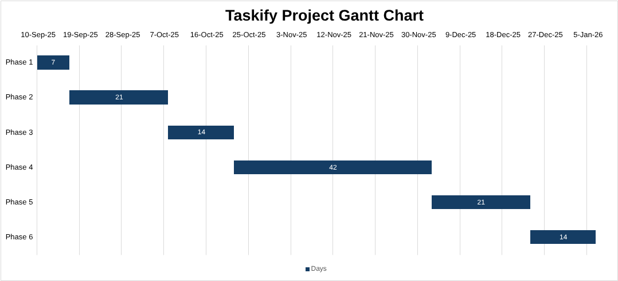
Fig. 1: Gantt chart for the project

Risk Management
Risk management involves the identification of problems that could threaten the project’s success and putting plans in place to handle them. For this project, I identified three main risks that threatened the completion of the project. I assessed how likely they were to happen (Likelihood) and how bad it would be if they did (Impact). The table below outlines these risks and the actions or contingencies I put in place to mitigate them.
Risk | Impact | Likelihood | Severity | Tracker | Action/Contingency
Computer crashing / Data loss | 10 | 5 | 50 | Edmund | (A) Set up the Google Drive for Desktop software to automatically back up all project files and documents to the cloud. I also used GitHub to push and back up my code versions regularly.
Including too many features | 8 | 8 | 64 | Edmund | (A) Prioritised the development of only the primary features needed to execute the basic functions of a to-do list app (Must Have). I set aside more advanced features (Should/Could Have) for future updates.
Insufficient storage capacity in the database | 9 | 10 | 90 | Edmund | (C) Switched from using Redis database to Qdrant database because Redis has a storage limit of 25 MB for free users, and Qdrant has 4 GB.
The first risk, computer crashing/data loss, is given a high impact rating (10/10) because if my computer crashes and I lose all my data without a backup, I would lose the entire project source code and reports and have to redo all of it. This would affect my ability to keep to the timeframe and meet the deadline. Its likelihood rating is medium (5/10) because while modern laptops are generally reliable, hardware/software failures and even theft happen often enough to be a real possibility during a long project.
The second risk, including too many features, is rated high on Impact (8/10) because if such a risk occurs, it could cause time slippage. "Must Have" features (like flagging tasks as important) may be rushed to make time for the fancy ones, leading to bugs and reduced quality of the core features. Furthermore, such unnecessary additions could reduce my time for writing the report or fixing critical errors before the project deadline. Notably, the risk has an equally high likelihood (8/10) due to the fact that I can get quite excited about projects I’m developing and will constantly brainstorm cool new features to add. Luckily, the risk was well mitigated thanks to the containment plan (action) implemented.
The final risk, insufficient storage capacity in the database, is given a high impact rating of 9/10 because running out of space on an active web application is a terrible situation. If the storage does fill up, the application will stop allowing users to create new tasks or save changes. This breaks the app’s core functionality, rendering it unusable. The likelihood of occurrence (10/10) is also high because Redis offers only 25MB on its free tier. Therefore, space can quickly be exhausted as vector data takes up more storage than simple text, especially when embedding-based search is included.

Configuration Management
Configuration management is the process of organising, managing, and tracking changes of all project assets. In a development workflow where files and code change constantly, proper configuration management is needed because you can easily overwrite important progress, misplace supporting files, or need to fall back to a previous stable version [source]. This section outlines how configuration management was handled for Taskify.
For this project’s configuration management, a lightweight approach was adopted. This involved a clear folder structure, automated cloud backup with built-in version history via Google Drive for documentation and Git/GitHub for source code version control and backup. This approach was chosen because it avoids the complexity and cost of heavy enterprise configuration tools while still making sure that every file was backed up, changes could be tracked, and previous states could be restored without manual file clutter (like having multiple copies such as Report_v1, Report_v2).
The items placed under configuration control included all artefacts produced during the project lifecycle:
- Documentation: Project proposal, project report, presentation slides, and demonstration report.
- Project Management: Microsoft Excel workbook containing the Work Breakdown Structure, Gantt chart, and timeline tracker.
- Design Models: Visual diagram files (Use Case diagram, Class diagrams, and Sequence diagram).
- Media and Assets: Screenshots of the UI, diagrams, and exported charts.
- Source Code: All application files, including SvelteKit routes, Svelte 5 components, TypeScript logic, CSS stylesheets, configuration files, and database connection scripts.
The supporting documents and files of the project were organised into a single main directory called TASKIFY PROJECT to keep all assets centralised. The application itself was stored in a separate folder to prevent it from syncing to Google Drive and instead sync to GitHub. The folder structure is laid out below:
TASKIFY PROJECT/ |  | (Main Project Folder)
DOCUMENTATION/ |  | (Reports, Presentation, and Project Management)
Project Report.docx |  | (Reports, Presentation, and Project Management)
Demonstration Report.docx
Presentation Slides.pptx
Project Management.xlsx
DIAGRAMS/ |  | (Files and images of the UML diagrams)
use case diagram.drawio
initial class diagram.drawio
final class diagram.drawio
sequence diagram.drawio
IMAGES/ |  | (UI and source code screenshots, diagram exports, and the Gantt chart)
TASKIFY APP/ |  | (SvelteKit application files)
- Documentation Versioning: Rather than manually creating separate draft files, versioning was managed through Google Drive's automated Version History. Every significant edit to the report or presentation was saved with a timestamp, allowing any previous state to be restored if needed.
- Code Versioning: The SOURCE_CODE directory operated as a local Git repository linked to a remote GitHub repository. After every development session, changes were committed and pushed to the main branch. This maintained a complete historical log of all code changes and provided a safe rollback point if new code caused issues.
For document versioning, Google Drive’s automated Version History managed it, rather than manually creating separate draft files
All configuration management items were physically stored and developed on an HP EliteBook PC running Windows 11. Google Drive for Desktop was used to automatically sync and store document files in the cloud, while GitHub was used to host the remote repository for the source code.

Testing

Conclusion

Chapter 6: Conclusion

References

Appendices

Phase 1: Project Initiation and Planning (7 days)
- Developing the initial project idea
- Securing approval for the project idea from my supervisor
- Drafting the project proposal
- Securing supervisor approval for the proposal
Phase 2: Analysis and Requirements Gathering (21 days)
- Conducting a review of existing solutions to inform the project's direction
- Gathering the system's functional and non-functional requirements
- Modelling a Use Case diagram to illustrate the interactions between users and the system
- Outlining the system’s architecture
- Modelling an initial class diagram to define the system's static structure
- Securing supervisor approval for the completed analysis and requirements documentation
Phase 3: Designing the system (14 days)
- Modelling the final, detailed class diagram, supported by an appropriate narrative
- Modelling a sequence diagram to describe the behaviour of a key system operation.
Phase 4: Implementing the system (42 days)
- Setting up the database schema using Qdrant Vector Store.
- Implementing the backend server-side logic, including user authentication and task management APIs.
- Developing the front-end user interface and connecting it to the backend services.
Phase 5: Testing the system and fixing bugs (21 days)
- Performing diverse black-box tests to verify that the application's features work as expected from a user's perspective.
- Developing and documenting unit and integration test scripts to validate individual components and their interactions.
- Identifying, logging, and systematically fixing any bugs, errors, or defects discovered during testing.
Phase 6: Final Documentation and Handover (14 days)
- Writing the final project report by fleshing out each chapter and arranging a comprehensive appendix.
- Ensuring the final source code is well-commented and clean.
- Preparing and delivering the final project presentation and demonstration.
- Printing and submitting all project deliverables, including the proposal document, final report, demonstration report, and presentation slides.

